COMPARATIVE STUDY OF LOW-CODE DEVELOPMENT VERSUS TRADITIONAL APPLICATION DEVELOPMENT APPROACHES
Department of Computer Science and Business System
By N S Anjan Adithya 241401011

Abstract
Software teams today must deliver applications faster than ever, which has led to the rise of low-code development alongside traditional, hand-coded approaches. This report compares the two methods across speed, cost, customization, scalability, security and maintainability, and explains where each performs best. Traditional development, using languages such as Java, Python and C#, offers full control and is preferred for large, complex, regulated systems. Low-code platforms such as Microsoft Power Apps, Mendix, OutSystems, Appian, Zoho Creator and AppSheet use visual, drag-and-drop tools to build applications quickly, and suit internal tools, prototypes and small-to-medium projects. The report presents a twenty-point comparison, key advantages and challenges of both approaches, short case studies, and emerging trends such as AI-assisted and hybrid development, concluding that the right choice depends on project complexity, budget, timeline and required control.

Introduction

Application development is the process of designing, building, testing and deploying software that helps users perform specific tasks. It has evolved from manual, code-heavy methods toward faster, more accessible approaches as businesses demand quicker delivery. Traditional development builds software by writing source code manually using programming languages and frameworks, giving developers complete control but requiring more time and expertise. Low-code development instead uses visual designers and pre-built components to assemble applications with minimal manual coding, making it faster and more accessible to non-specialist "citizen developers". This report studies both approaches in detail, compares them across key parameters, and offers guidance on choosing the right one for a given project.

Traditional Application Development

Traditional development follows the Software Development Life Cycle (requirement analysis, design, coding, testing, deployment and maintenance), typically using Waterfall or Agile methodologies. Developers write code in languages such as Java, Python, C# or JavaScript, using frameworks like Spring Boot, Django, React or .NET, and can architect systems (client-server, three-tier, microservices) exactly to their performance and security needs. This gives complete control and unlimited customization, making it the preferred choice for banking systems, airline reservation platforms, ERP software and other complex, regulated, mission-critical applications. The trade-off is longer development time, higher cost, and a need for experienced developers.
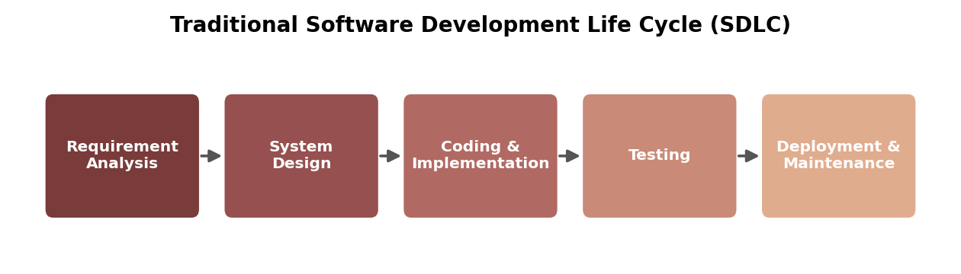
Figure 1: Traditional Software Development Life Cycle (SDLC)

Low-Code Development

Low-code development uses a visual designer, a model-driven engine, pre-built connectors and a managed runtime to let developers assemble applications through drag-and-drop screens, workflow builders and configuration rather than extensive coding. Popular platforms include Microsoft Power Apps, Mendix, OutSystems, Appian, Zoho Creator and AppSheet, each varying in enterprise scale, automation focus, and affordability. This approach dramatically shortens development time and lowers the technical bar for contributors, making it ideal for internal business tools, workflow automation and rapid prototypes. Its limitations include restricted customization, dependency on the platform vendor, and potential performance constraints for very large systems.
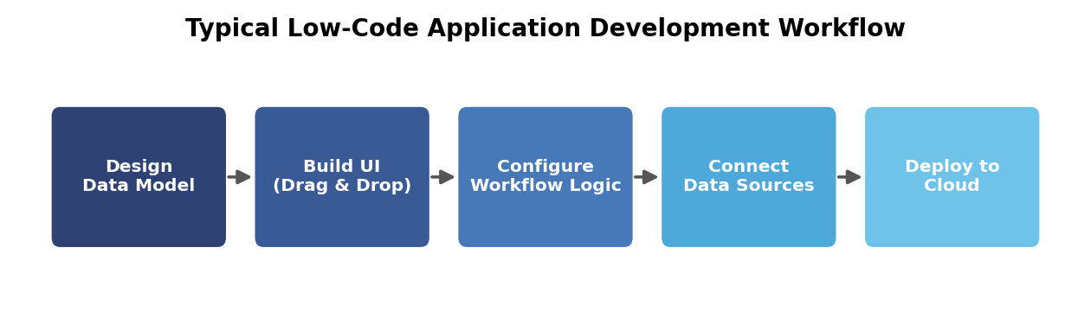
Figure 2: Typical low-code application development workflow

Comparative Study

The table below compares both approaches across twenty key parameters that most influence a project's technology choice.
# | Parameter | Traditional Development | Low-Code Development
1 | Development Speed | Slower; manual coding | Fast; visual, reusable components
2 | Coding Effort | High | Minimal
3 | Learning Curve | Steep | Gentle
4 | Cost | Higher upfront (labour) | Lower upfront, recurring licence fees
5 | Customization | Very high | Limited to platform
6 | Scalability | Fully controllable | Depends on platform limits
7 | Performance | Optimisable precisely | Good, but can lag for heavy loads
8 | Security | Custom-built, team-owned | Vendor-managed
9 | Flexibility | Extremely flexible | Restricted to templates
10 | Deployment | Manual setup | One-click, cloud-hosted
11 | Maintenance | Can get complex | Simplified by vendor updates
12 | Integration | Custom-coded | Built-in connectors
13 | User Interface | Fully custom | Pre-built components
14 | Testing | Manual + automated frameworks | Often built into platform
15 | Debugging | Full code access | Limited visibility
16 | Vendor Dependency | None | High
17 | Cloud Support | Configured manually | Usually built-in
18 | Time to Market | Longer | Much shorter
19 | Collaboration | Mostly technical teams | Business + IT together
20 | Best Use Cases | Large, complex, regulated systems | Internal tools, prototypes, SMB apps
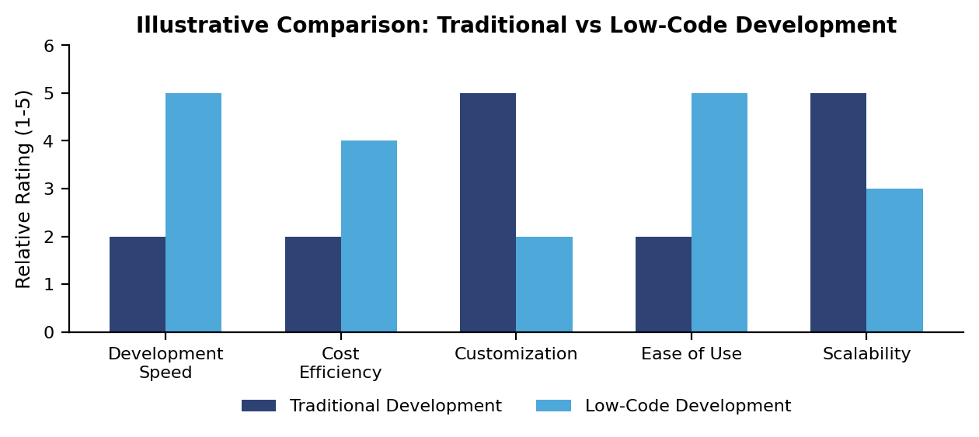
Figure 3: Illustrative relative comparison across key parameters
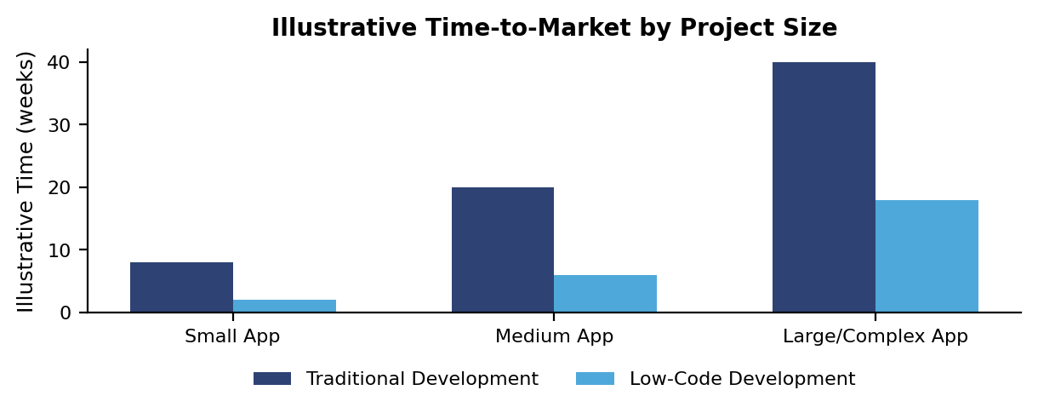
Figure 4: Illustrative time-to-market by project size

Notes on Selected Comparison Points

- Development Speed: manual coding of every screen and integration extends traditional timelines, while low-code's pre-built components let teams assemble working software much faster.
- Cost: skilled developers and longer timelines make traditional projects costlier upfront, whereas low-code lowers initial cost but adds recurring licensing fees over time.
- Customization: hand-written code allows nearly unlimited customisation, while low-code restricts developers to the components and extension points the vendor provides.
- Scalability: traditional systems can be architected precisely for expected load, while low-code applications scale only as far as the underlying platform allows.
- Security: traditional teams design and own their security measures directly, while low-code relies on the vendor's built-in protections and practices.
- Maintenance: large traditional codebases can grow hard to maintain without discipline, while low-code maintenance is simplified through vendor-managed updates.
- Vendor Dependency: traditional applications remain independent of any vendor, while low-code applications stay tied to the chosen platform's pricing and roadmap.
- Time to Market: the manual work in traditional development extends delivery timelines, while low-code is built specifically to shorten time to market.

5. Advantages and Challenges
Both approaches carry distinct strengths and limitations, summarised below.
Approach | Key Advantages | Key Challenges
Low-Code | Faster delivery; lower cost for small/medium apps; usable by citizen developers; built-in scalability and cloud hosting; encourages business-IT collaboration. | Vendor lock-in; recurring licensing cost; limited customization; performance limits for heavy workloads; migration difficulty.
Traditional | Full control and customization; best performance and security tuning; no vendor dependency; suited to complex, regulated, large-scale systems. | Longer timelines; higher cost; needs experienced developers; harder long-term maintenance; longer testing cycles.

5.1 Additional Points to Consider

- Prototyping speed: low-code lets teams validate an idea with a working demo in days, which is valuable before committing budget to a full traditional build.
- Total cost of ownership: traditional projects cost more upfront but avoid ongoing per-user licence fees, so total cost over many years can sometimes be lower for large, long-lived systems.
- Talent availability: traditional development depends on hiring or training skilled programmers, while low-code broadens who can contribute to building software.
- Regulatory audits: traditional codebases are easier to audit line-by-line for compliance, whereas low-code compliance relies partly on the vendor's certifications.

Case Studies

A mid-sized retail company with a small IT team needed an inventory-tracking tool quickly, so it used Microsoft Power Apps to build and deploy a working application in about three weeks, relying on the platform's connectors and managed hosting. In contrast, a large bank building a core transaction-processing system chose traditional Java-based microservices development, since the project demanded very high performance, strict regulatory compliance and deep integration with legacy infrastructure that no low-code platform could support. These examples illustrate how project scale, complexity and available expertise shape the right choice of approach.

Future Trends

- AI-assisted and generative development: AI tools increasingly write, suggest and even generate application code and prototypes from plain-language descriptions.
- Hybrid development: organisations increasingly combine low-code for simple, fast projects with traditional development for complex, mission-critical systems.
- Citizen development and DevOps: low-code platforms are gaining DevOps practices (version control, testing) while empowering more non-technical business users to build their own tools.
- Cloud-native applications: both approaches are moving toward cloud-native architectures that offer better resilience, scalability and cost efficiency.
- No-code evolution: no-code tools, needing even less technical skill than low-code, are expanding access to application building for a wider range of business users.

8. Conclusion
Traditional development remains the stronger choice for large, complex, highly regulated systems requiring full control and performance tuning, while low-code development offers clear advantages in speed, cost and accessibility for internal tools, prototypes and small-to-medium applications. Neither approach is universally superior; many organisations now adopt a hybrid strategy, choosing the method that best matches each project's scale, budget, timeline and required customization.
As artificial intelligence and cloud technologies continue to mature, the gap between the two approaches is likely to narrow further, with AI-assisted coding tools speeding up traditional development and low-code platforms gaining more advanced customization options. For students and new developers, understanding both approaches, and knowing when to apply each, is becoming an essential skill in modern software engineering.

9. References
1. Pressman, R. S., & Maxim, B. R. (2020). Software Engineering: A Practitioner's Approach (9th ed.). McGraw-Hill.
2. Sommerville, I. (2016). Software Engineering (10th ed.). Pearson Education.
3. Gartner. (2023). Magic Quadrant for Enterprise Low-Code Application Platforms.
4. Microsoft. (2024). Power Apps Documentation. Microsoft Learn.
5. Mendix. (2024). Mendix Platform Documentation. Mendix B.V.
6. OutSystems. (2024). OutSystems Developer Documentation.
7. IBM. (2023). Low-Code and No-Code Development: An Enterprise Perspective.
8. Oracle. (2023). Application Development Approaches for the Modern Enterprise.
9. IEEE. (2022). Comparative Analysis of Low-Code Platforms and Traditional Software Development.
10. Appian. (2024). Low-Code Automation Platform Documentation.
11. Zoho. (2024). Zoho Creator Developer Guide.
12. Google Cloud. (2024). AppSheet Documentation.

